Pareto analysis

Purpose
The purpose of Pareto Analysis is to statistically determine the limited number of causes (20%) that produce a large majority of problems (80%). This will enable the team to quickly focus its efforts on the key causes of a problem.

Main Description
The Pareto Principle states that only a "vital few" factors are responsible for producing most of the problems. Pareto analysis is a formal technique useful where many possible courses of action are competing for your attention. In essence, the problem-solver estimates the benefit delivered by each action, then selects a number of the most effective actions that deliver a total benefit reasonably close to the maximal possible one.
  - WHY to use
- To separate the vital few from the trivial many that are causing the greatest number of defects
- To sort the data for determining the focus of improvement efforts
- To find out the severity of the problems
- To find out the frequency of different causes
- To guide the most appropriate corrective action

  - WHEN to use
To help in decision making, after doing a cause-and-effect analysis, to count the frequency of different causal factors, and to identify problems
  - HOW to use
Steps:
- Determine the classifications (Pareto categories) for the graph.
If the necessary information does not exist yet, it is possible to use check sheets to obtain it.
- Form a table listing the causes and their frequency as a percentage.
- Arrange the rows in the decreasing order of importance of the causes
(i.e., the most important cause first)
- Add a cumulative percentage column to the table
- Plot with causes on x- and cumulative percentage on y-axis
- Join the above points to form a curve
- Plot (on the same graph) a bar graph with causes on x- and percent frequency on y-axis
- Draw line at 80% on y-axis parallel to x-axis. Then drop the line at the point of intersection with the curve on x-axis. This point on the x-axis separates the important causes (on the left) and trivial causes (on the right).

  - Limitations/Shortcomings
None

Deliverables
Pareto Chart

Related tools / techniques
- Check sheets

Example
This is a simple example of a Pareto diagram using sample data showing the relative frequency of causes for errors on websites. It enables you to see what 20% of cases are causing 80% of the problems and where efforts should be focused to achieve the greatest improvement.

Rank | Category | Count | % | Cum %
1 | Broken link | 350 | 35 | 35
2 | Spelling error | 300 | 30 | 65
3 | Missing image | 250 | 25 | 90
4 | Script error | 100 | 10 | 100

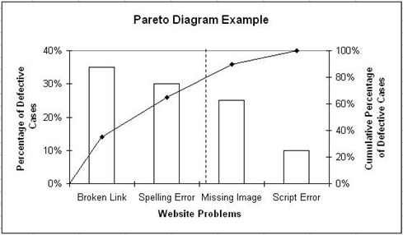

Template
Not applicable

Sources/References
- http://www.isixsigma.com
- http://en.wikipedia.org
- http://erc.msh.org/quality/example/exampl22.cfm

